Shot Put

Weights

The table below shows the specific weights for each age group.

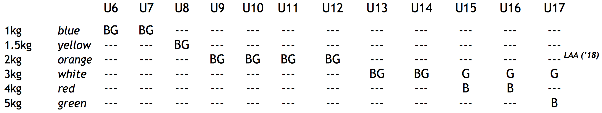

Technique and Process
The object is to project the shot as far as possible using a correct 'putting' (not throwing) technique.
During the put:
    - The athlete must put the shot with one hand only
    - The attempt begins with the athlete in a stationary position within the circle.
    - The shot must touch or be in close proximity to the neck, chin or cheek at all times from when the athlete takes their stance in the circle, until the put is made
    - The hand/shot must not drop from this starting position, or move behind the shoulders
    - The athlete cannot step forwards out of the circle, or place a foot on top of the circle rim or stopping board (if there is one)
        - His/her first step outside the circle must be behind the line that joins the sides of the circle.

The attempt is deemed a foul if:
    - The athlete does not put from the shoulder with one hand
    - The attempt does not commence with the athlete in a stationary position in the circle, and the shot resting against the cheek or just under the jaw
    - The shot/hand drops below the starting position, or moves behind the line of the shoulders
    - The elbow moves in front of the putting hand during the attempt
    - The shot does not land within the arc described by the 2 lines extending from the circle (note that touching the line = foul attempt)
    - The athlete moves out of the circle before the shot has landed
    - The athlete makes contact with the top of the stop board or any part of the ground outside the circle in front of the line connecting the sides of the circle
    - The athlete leaves the circle other than behind the line connecting the sides of the circle
            - (Note that it is our preference that athletes also enter the circle from behind this line, for added safety, but there is no specific competition rule in this regard)

Measurement
    - The spike is placed in the nearest point of the imprint the shot made when landing
    - The tape should be held taut, such that it passes through the centre of the circle
    - The measurement is read from the inner circumference of the circle
    - The measurement is rounded down to the nearest whole centimetre
    - The athlete's final result is the largest of their 3 throws

