Javelin

Weights

The table below shows the specific weights for each age group

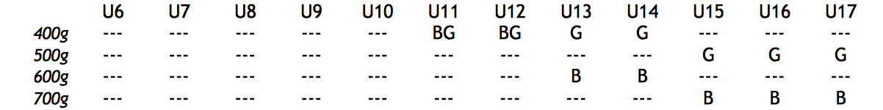

Technique and process
The object is to throw the javelin as far as possible from within the run-up area, using the correct technique:
- The javelin must be held at the grip
- The javelin must be thrown over-arm, such that it passes over the shoulder or upper part of the arm. ‘Slinging’ or ‘hurling’ styles are not permitted
- The metal head of the javelin must strike the ground first. If this occurs, it is a fair throw even if the javelin does not ‘stick’ into the ground.
- The athlete must leave the runway only after the javelin has landed, and must leave behind the curved ‘foul’ line at the end of the runway

The attempt is deemed a foul if:
- The athlete touches or goes beyond the side lines marking the runway during the attempt
- The athlete touches the curved ‘foul’ line at the end of the runway, or any part of the ground beyond that.
- The metal head of the javelin is not the first part to make contact with the ground
- The javelin’s first contact with the ground is not within the lines marking the ‘throwing arc’ (touching the line = foul)
- The athlete leaves the runway before the javelin has landed
- The athlete leaves the runway in front of the foul line

Measurement
The spike/zero end of the tape is placed where the metal head/point of the javelin first struck the ground
The tape is pulled taut through the point of intersection of the arc lines (usually about 8m behind the ‘foul’ line on the runway). For Friday nights where javelin is done on the rugby field, the tape can be pulled back to cross the line nearest to the point from where the athlete threw the javelin.
The measurement is taken where the tape crosses the inside (furthest back) edge of the line.

