Discus

Weights

The table below shows the specific weights for each age group.

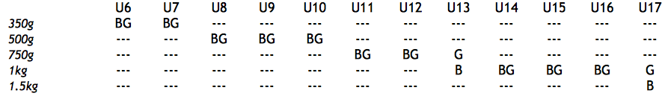

Technique and Process

The object is to throw the discus as far as possible from inside the circle. Unlike shot put and javelin, there is no specific rule about how the discus may be thrown. A variety of techniques may be used, but generally athletes are encouraged:
- to hold the discus such that the four fingers of the throwing hand curl over the edge of the discus (the hand will be on top of the discus during the throw)
- to place the thumb on top of the discus (not holding the edge)
- to use a ‘side arm’ throw with a straight arm, projecting the discus upwards
- to release the discus off the index finger (between it and the thumb)

The throw is deemed a foul if:
- The attempt does not commence with the athlete in a stationary position within the circle
- During the throw, any part of the athlete’s body touches the top of the circle rim, or the ground outside the circle.
- The athlete leaves the circle before the discus has landed
- The discus lands outside or touching the lines marking the ‘V’ sector in front of the circle. (Note that a throw can be deemed legal if it hits the net or cage around the circle, as long as it then lands within the ‘V’ sector).
- The athlete leaves the circle other than behind the line connecting the sides of the circle
- (Note that it is our preference that the athlete also enters from the rear of the circle for safety, but there is no specific competition rule in this regard).

Measurement
- The spike is placed in the nearest point of the imprint the discus made when landing
- The tape should be held taut, such that it passes through the centre of the circle
- The measurement is read from the inner circumference of the circle
- The measurement is rounded down to the nearest whole centimetre
- The athlete's final result is the largest of their 3 throws

